Experiment 30
You and your team are working on a project. One team member adds a new feature to the project. You need to fetch the latest changes, create a new branch, and implement your feature without affecting the existing code.
Tasks:
- Fork a repository (you can use an existing repository or a partner’s repository).
- Clone the repository to your local machine.
- Create a new branch for your feature.
- Implement your changes and push them to your forked repository.
- Submit a pull request to the original repository.
Step 1 — Open the original repository
https://github.com/Aamna7868/library-project.git
Step 2: Fork the Repository
The Fork option was selected.
The repository was forked into my GitHub account.
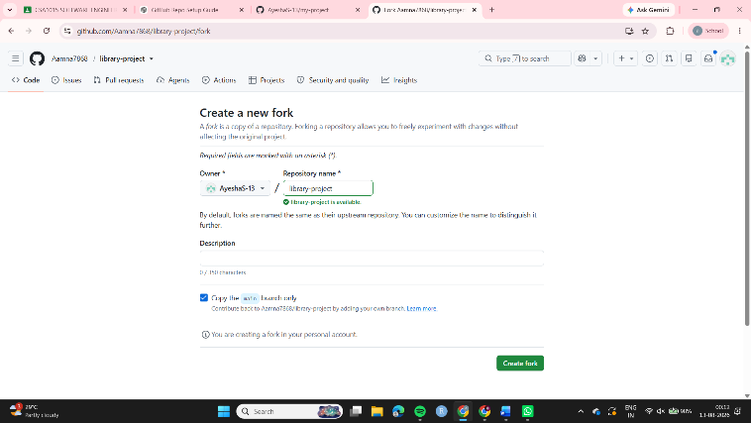
Step 3: Clone the Forked Repository
The HTTPS URL of the forked repository was copied using Code → HTTPS.
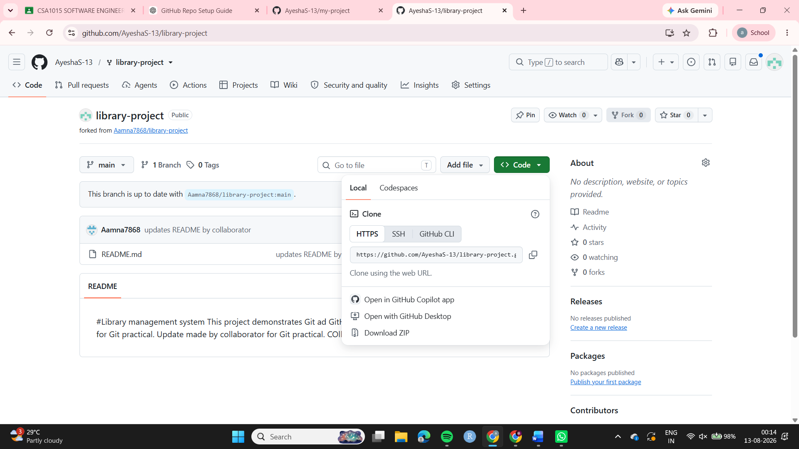
Step 4: Navigate to the Repository
cd library-project
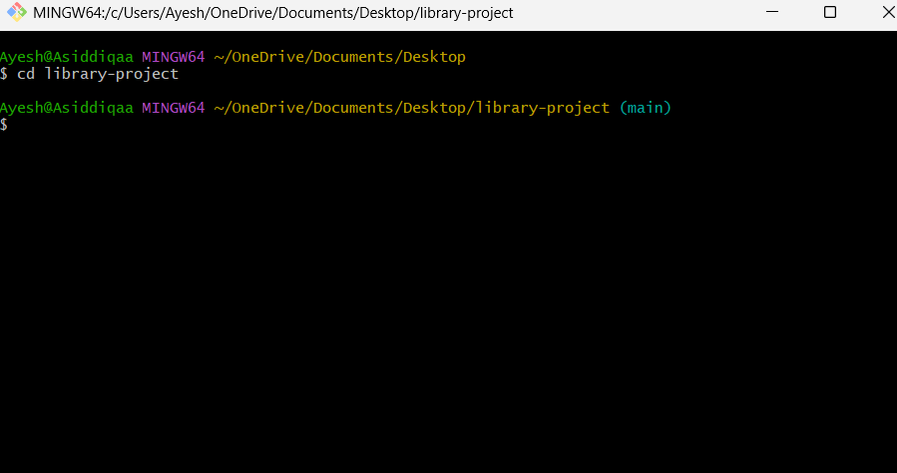
Step 5: Create a Feature Branch
A new branch named feature-search was created:
git checkout -b feature-search
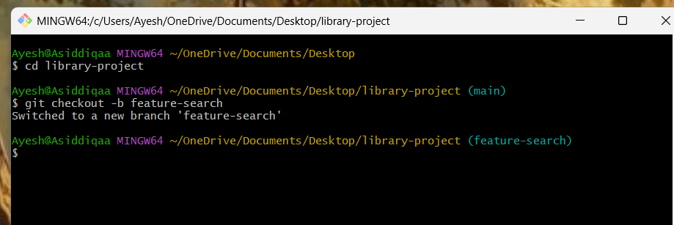
Step 6: Implement the Feature
A new file named search.py was created to implement a simple book search feature.
Notepad search.py
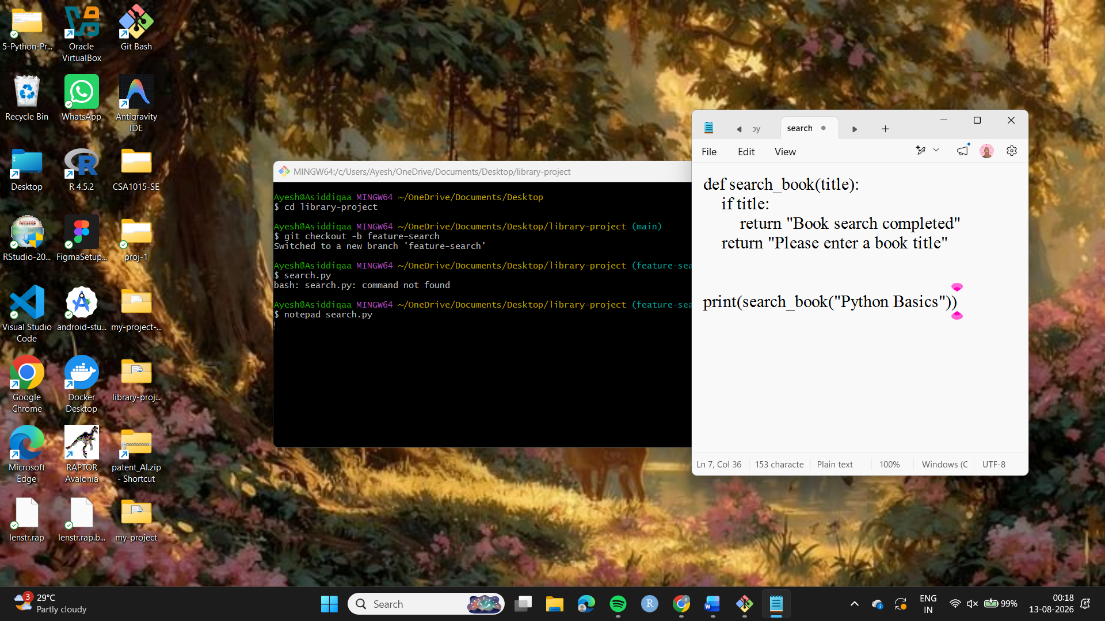
Step 7: Stage the Changes
git add search.py
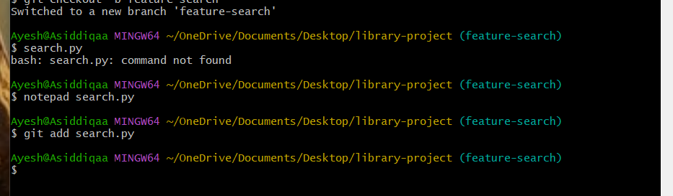
Step 8: Commit the Changes
git commit -m "Added book search feature"
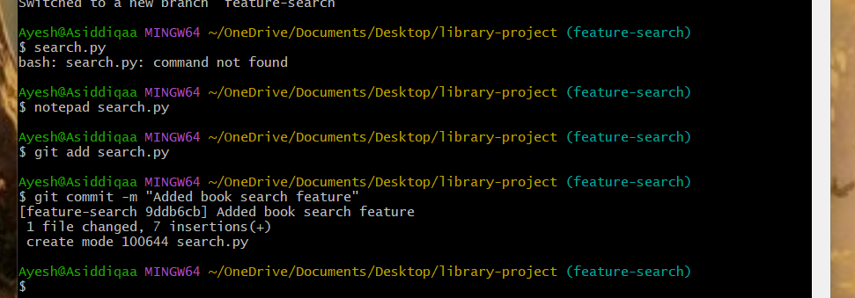
Step 9: Push the Feature Branch to the Fork
git push -u origin feature-search
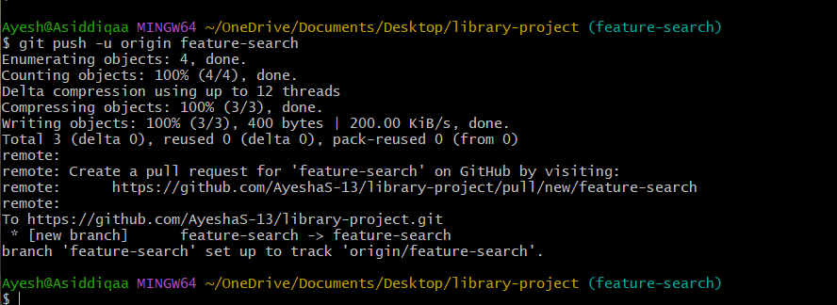
Step 10: Create a Pull Request
On GitHub, Compare & pull request was selected.
The Pull Request was configured as:
Base repository: Aamna7868/library-project
Base branch: main
Head repository: AyeshaS-13/library-project
Compare branch: feature-search
Thus, the Pull Request was created from:
AyeshaS-13/library-project
feature-search -> Original repository (main)

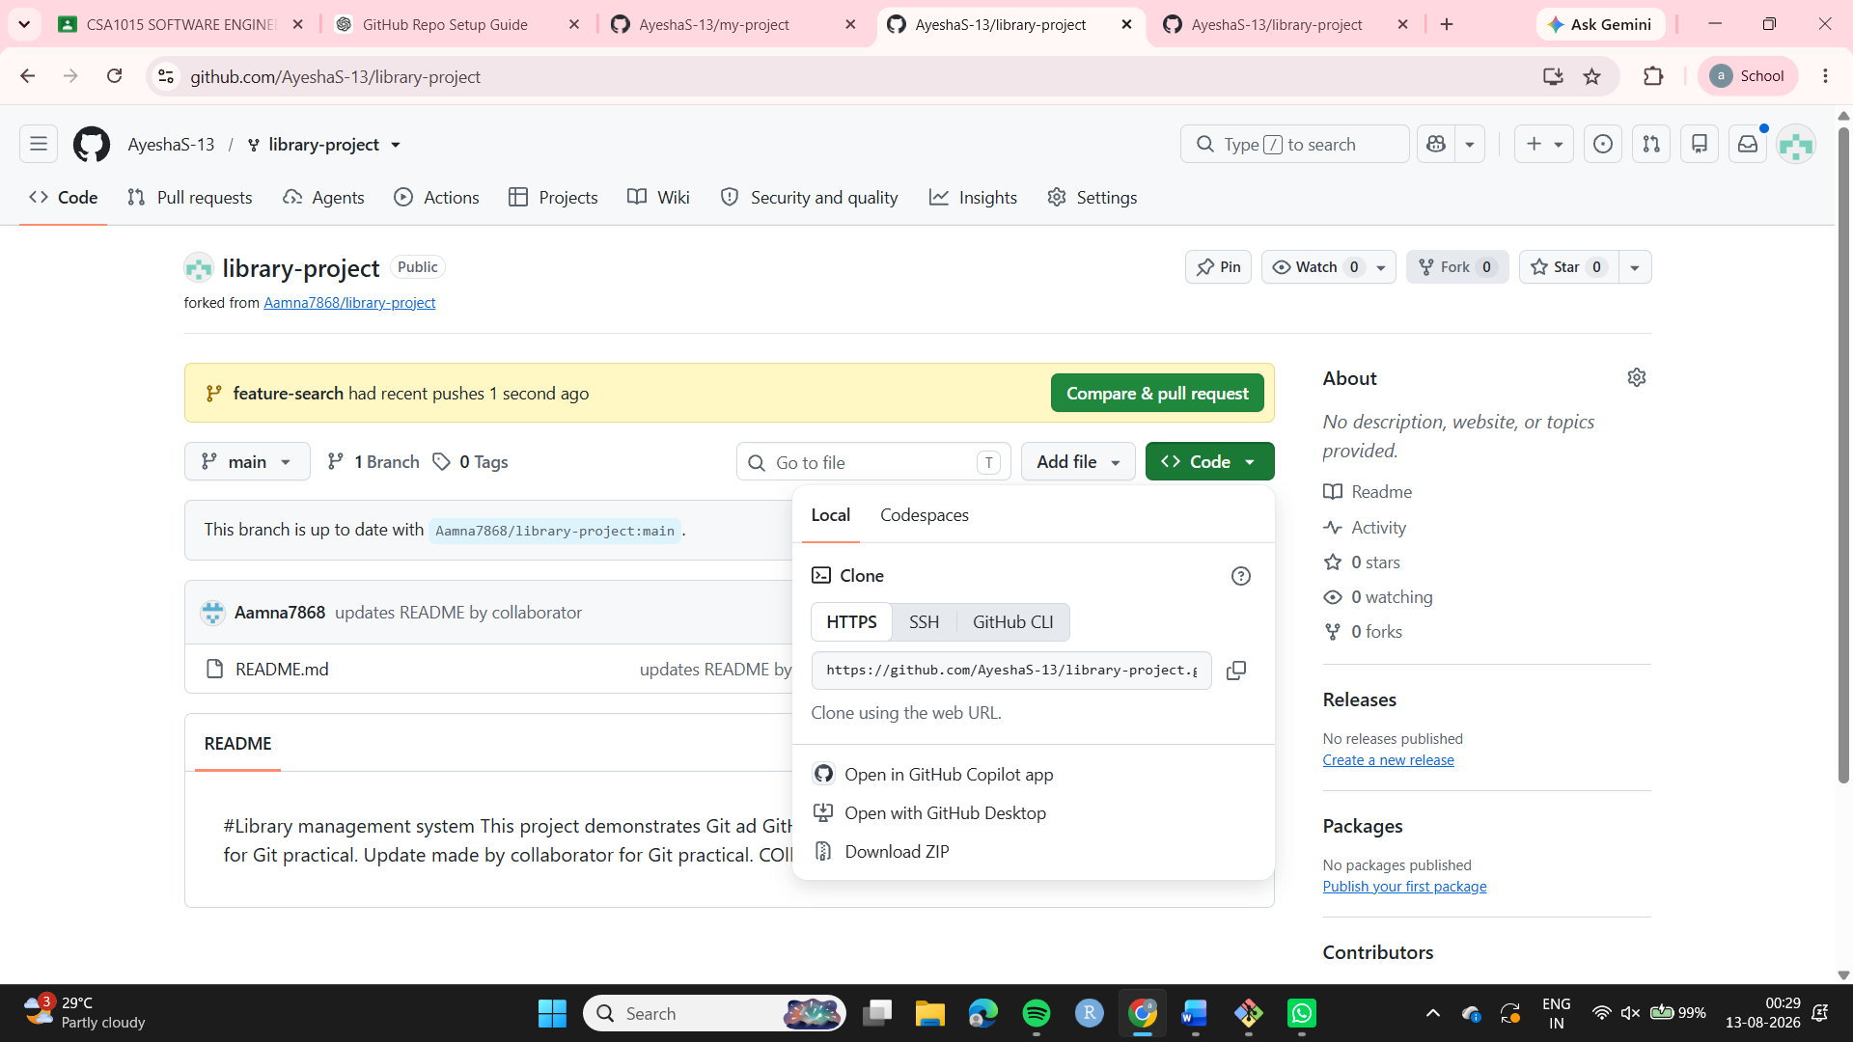
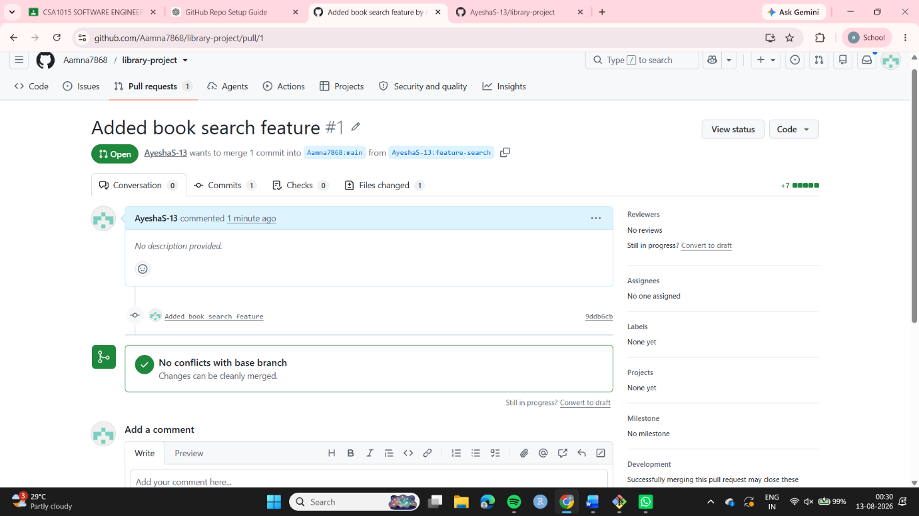

Result
The original GitHub repository was successfully forked and cloned. A new feature-search branch was created and a book search feature was implemented. The changes were committed and pushed to the forked repository. A Pull Request was successfully submitted from the feature branch to the main branch of the original repository.

